

2 Minute Form
Trip Name: Tutukaka & Poor Knights
Check-in Name and Phone:
Date: Branch:
Leaders
Cell Phone Number
VHF Call Sign &/or Vessel Name
Vehicle make, model, registration, colour
General Plan
Note: If plan changes, you must notify your Check-in person.
Latest Time Off the Water |  |  |  |  | TMP used²⁰
Tide/ Forecast Lake Level | Low |  |  | High | Other
Communications Carried²¹ | VHF, cell phone, PLB
Communications | We will be communicating as a group on VHF Channel __8___
Equipment Carried | Usual kayak gear, helmets for rock gardening.
Trip Report
(Use other side if more space required)

Activity | Tutukaka | Centre | Auckland | Location |  |  |  | Northland |  | Difficulty¹ |  |  |  | intermediate
Activity Description | Stay at Tutukaka, 2-3 days paddling in the area before returning home. Plenty of excellent rock-gardening along the coast in both directions. Optional extra is a day trip to the Poor Knights Islands(details below). |  |  |  | Leader qualification req.² |  |  | Club leader
Get in Location | Tutukaka |  |  |  | Chart/ Map no.⁴ |  |  | 5211 |  | Distance |  |  |  | various
Get out Location | Tutukaka |  |  |  | Coastguard Channel |  |  | Tutukaka |  | Nowcasting |  |  |  | 21
Emergency get out ⁵ | Any beaches along the coast |  |  |  | Emergency / Coastguard Station / Weather |  |  | 85 & 16 |  | Phone |  | *500 / 09 303 4303
Emergency get out ⁵ |  |  |  |  | Drinking Water⁶ |  | Yes |  | Toilets⁷ |  |  |  | Yes
Emergency Response | Refer Emergency Response Booklet |  |  |  |  |  |  |  | Parking⁸ |  |  |  | Yes
Specific Equipment Required⁹ | Recommend that you take helmets if planning on rock gardening or surfing. |  |  |  | Working Communications equipment in this area¹⁰ |  | Cell phone  Sat phone |  |  |  | Mountain Radio |  |  |  | PLB  VHF
Other resources  and notes¹¹ | Day 1: Paddle north from the Tutukaka Harbour, and head up along the rocky coastline exploring the caves, archways and inlets, stopping for lunch at Matapouri Bay or Whale Bay if time and conditions allow. Catch some surf at Matapouri Bay if conditions oblige. The round trip will be around 24kms.  Day 2: Paddle south along the rocky coastline, past Rahomaunu Island and in to Ngunguru Inlet or on past Whangaumu Bay with its stunning long white sandy beach to Goat Island. Return trip from Ngunguru is around 12km. |  |  |  | Weather Parameters¹² | Beginner: no significant surf or swell, wind under 15 knots.  Intermediate: surf or ocean swells less than 1.5 metres or wind under 25 knots.  Advanced: any condition that’s suitable for the trip’s aims.
Previous incidents¹³

Safety Management¹⁴
Hazard |  | Significant?  - E/I/M |  | Management Strategy¹⁵ |  |  |  | Hazard | Significant?  - E/I/M | Management Strategy¹⁵
Cold Water |  | Yes - M |  | Carry spare dry clothes and shelter |  |  |  | Deep Water | Yes - E | Correctly fit PFDs
Medical Conditions |  | Yes - M |  | - Leader has first aid qualification  - Ask customers about medical conditions |  |  |  | Bad Weather | Yes - M | Understand weather forecasts.  Have back up plans or pull out if necessary
Capsizing |  | Yes - M |  | - Correctly fit PFDs  - Skills at performing rescues. |  |  |  | Heat / Sun | Yes - M | - Protective Clothing (worn), Sunglasses, Hat  - Sun Screen  - Plenty of drinks
Panic |  | Yes - M |  | Ensure conditions match level  of skills |  |  |  | Obstacles | Yes - M | Awareness of reefs, navigational hazards, nets
Rocks |  | Yes-M |  | If there is any significant swell, participants should wear a helmet if going rock gardening. Ensure participants have appropriate skills. |  |  |  | Other Vessels | Yes - M | - Understand the “rules of the sea”  - “Be seen” – Have two of the following; flag, brightly coloured kayak, brightly coloured Pfd or hat. At night: an all- round white light & a powerful torch.
Surf Landings |  | No –E |  | Take care at Ngunguru Bar and Matapouri Bay if there is any swell as surf can be challenging there. Avoid or play depending on conditions and ability of the group. Ensure participants have appropriate skills. Manage the landing if necessary.
Written up by: | Larraine Williams |  | Approved By: |  | Russell Williams | Signed: | RW |  | Date: | 1 September 2014 | Review in: | 12 months from date of approval

Additional Information Sheet (Optional)
Introduction (A general introduction)
Description (A description of the tour – as if you were selling the idea to someone) |  | Discover the incredible beauty of the Tutukaka region, with heaps of paddling opportunities and a great day trip out to the Poor Knights Islands marine reserve, aboard the 'Perfect Day', to kayak, swim and go snorkelling. It’s a fantastic bit of coastline, with lots of rock gardening. Bring your camera. Information on the Poor Knights...
Local Attractions |  | Transport/ Local Operators
 | Contact details | Perfect Day – Poor Knights trip | http://www.aperfectday.co.nz/
Local Eateries
 | Contact details
Accommodation/ Campsite Locations |  |  | Facilities
Name | Pacific Rendevous Motel |  | Cabins | No | Fuel | ?
Phone | 0 9 4343 847 |  | Showers | Yes | Power | yes
E-mail | resort@pacificrendezvous.co.nz |  | Toilets | Yes | Water Access | ?
Website | http://pacificrendezvous.co.nz/ |  | Laundry | Yes | Pool | yes
Physical Address | 73 Motel Road, Tutukaka  Whangarei, Northland |  | Water | Yes | Fires Allowed | no
Other |  |  | Supplies | ?
Other information

Accommodation/ Campsite Locations |  | Facilities
Name | Tutukaka Holiday Park | Cabins | Yes | Fuel | ?
Phone | 09 434 3938 | Showers | Yes | Power | yes
E-mail | tutukakaholidaypark@gmail.com | Toilets | Yes | Water Access | ?
Website | http://www.tutukaka-holidaypark.co.nz/ | Laundry | Yes | Pool | ?
Physical Address | RD 3 Whangarei | Water | Yes | Fires Allowed | no
Other |  | Supplies | ?
Other information

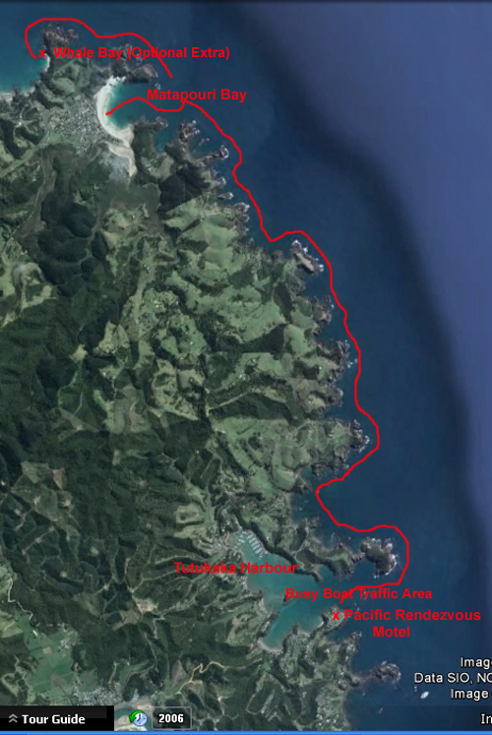
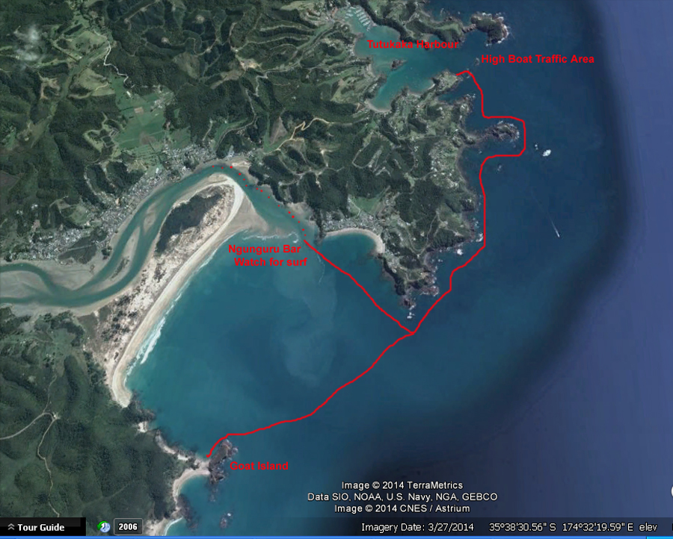

Activity Equipment Check list
Equipment List
- Helmet (rivers & surf) Group Gear
❑ Beanie / hat  Split paddles
❑ Thermals  Repair kit
❑ Paddle Jacket  Fire lighting
❑ PFD  Cooker/thermos
❑ Spray deck  Spare thermals
❑ Booties  Tow system
❑ Water & food  1st Aid Kit
❑ Kayak & paddle  Flares
Group - Oceans & Lakes  Compass
❑ Pumps & Paddle Floats  Charts / Maps
Group - River  GPS (optional)
❑ Throw ropes  Knife (cut rope)
❑ Pin kit & saw  Emergency Shelter

In case of emergency: Dial 111, Mayday :VHF Channel 16

Kayaking Check list

❑ Trip plan
❑ Latest weather forecast
❑ Conditions match skills?
❑ Hyperthermia (hot) &
Hypothermia (cold)
❑ On & off water safety
❑ Environmental concerns
❑ Emergency Procedures include emergency get out.
❑ Working communication devices
e.g. VHF radio, mobile phones, PLB
❑ Specific safety issues for this trip
❑ Participant list
❑ Any medical conditions
❑ All participants keen to proceed?

❑ Trip Plan/ 2-minute form lodged with Ops. Manager

Appropriate wind conditions to run trips:
Novice - no significant surf or swell, wind under 15knots
Intermediate- surf or ocean swells less than 1.5 metre or wind under 25 knots.
Advanced- any condition that is suitable to the trips aims

At conclusion of trip:
Contact check in person
Group Debrief.

Check in Person Ph:
__________________ Mobile
__________________ Work
__________________ Home

Activity Document Cover Sheet

Activity:
Date of Activity:

Activity reports. Is all relevant information present:
– Approved Trip Management Plan (TMP)/ 2 minute form
– Club Trip Participant Sheet
– Weather forecast
– Activity Check List
– Trip report (May be on the 2 minute form)
– Accident / incident reports
Leaders Signature:
Date:

